CelDial: Case Study Analysis

INTRODUCTION
- CelDial Corporation started as a manufacturer of cell phones.
- It quickly expanded to include a broad range of telecommunication products
- As the demand for, and size of, their products grew, CelDial closed down the distribution channels and opened their own sales outlets.
- In the past year CelDial opened new plants, sales offices, and stores to meet increasing customer demand for their products.
- Celdial’s focus shifted towards expansion, their overall growth started to wear off. As a result the company wants to restructure to improve the performance.
- Sales and revenue figures are available for the entire organization, but the client wants the sales and revenue figures for individual outlet level, to analyze and restructure.

OBJECTIVE

To create a data warehouse to facilitate the analysis of cost and revenue data for products manufactured and sold by CelDial.

1. Operational System

Product information is added to the company’s records only after it has been tested, defined and approved by the research groups of the manufacturing plants. Each product can be produced by all manufacturing plants.

Apart from some base components that are required to produce all the required models, there exits additional components needed to manufacture specific models of the product.
The plants maintain an inventory of the product models. The models are stored here until they must be supplied to the various sales outlets. When the quantity of a particular model falls below a specified limit, the plant is made to produce more of that model.
When the company stops manufacturing a model, its data is retained for six months, until the last unit of the model is sold or removed.

The sales outlets are responsible for CelDial’s sales. There are two types of sales outlets- Corporate Sales Offices and Retail stores.

For retail stores, the product is sold over the counter and, while the product sales are recorded, the associated customer information is not required or used by CelDial.

Corporate sales offices offer their services to, and take orders from corporate customers, alone, and they are charged the wholesale price. A model can be sold at a discount when the customer buys in large quantities or in different model combinations. One of CelDial’s 30 sales representatives is assigned to each customer and orders can be placed through them. Customers can also place orders via phone-calls to the order desk of the sales offices.
The corporate sales outlets place the orders to the closest manufacturing plant. These orders are shipped directly from the plant to the customer’s multiple shipping locations, wherein the order is split into individual orders for each location.

2. Data warehouse System
- Modeling the target warehouse data is the process of translating requirements into a picture along with the supporting metadata that represents those requirements.
- Although we separate the requirements and modeling discussions for readability purposes, in reality these steps often overlap. As soon as some initial requirements are documented, an initial model starts to take shape. As the requirements become more complete, so too does the model
SCOPE OF THE PROJECT

- The project shall be limited to direct costs and revenues associated with products
- CelDial’s manufacturing costs cannot be allocated at the product level. Therefore, only component costs can be included.
- Rules for allocation of manufacturing and overhead costs may be created, so the data warehouse should be flexible enough to accommodate future changes.

UNDERSTANDING & ANALYZING REQUIREMENTS - Design Approach:
- User-driven requirements gathering is a method based on defining the requirements by investigating the functions the users perform. This is usually done through a series of meetings and/or interviews with users.
- We believe user-driven requirements gathering is the approach of choice, especially when developing data marts.
- For a full-scale data warehouse, we believe it would be worthwhile to use the source-driven approach to break the project into manageable pieces, which may be defined as subject areas.
- The user-driven approach could then be used to gather the requirements for each subject area.
What Do the Users Want?
1. What is the average quantity on hand and reorder level this month for each model in each manufacturing plant?
2. What are the total cost and revenue for each model sold today, summarized by outlet, outlet type, region, and corporate sales levels?
3. What are the total cost and revenue for each model sold dialy from each outlet?
4. What percentage of models are eligible for discounting, and from those, what percentage was actually given on sale, by store, for all sales happening in a week and each month?
5. For each model on a monthly basis, what is the percentage sold on retail, the percentage sold on corporate through an order desk, and the percentage sold by a salesperson?
6. Which models and products have not sold in the last week? The last month?
7. What are the top five models sold last month by total revenue? By quantity sold? By total cost?
8. Which sales outlets had no sales recorded last month for each of the models in each of the three top five lists?
9. Which salespersons had no sales recorded last month for each of the models in each of the three top five lists?

Conceptual Model Design
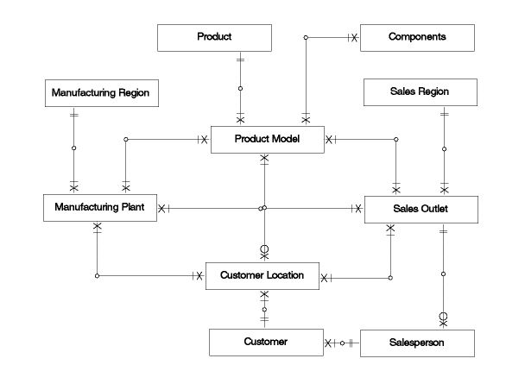
Entity Details
ENTITY |  | FACT/DIMENSION
Sales |  | Dimension
Manufacturing |  | Dimension
Product |  | Dimension
Time |  | Dimension
Order |  | Dimension
Sale |  | Fact
Inventory |  | Fact

Fact  Dimension | Total Qty sold | Total Qty produced | Re-Order Level | Total Revenue | Total Cost | Discount
Sales fact | ✓ |  |  | ✓ | ✓ | ✓
Customer_dim
Seller_dim
Manufacturing_dim
Time_dim

Order_dim ✓
Product_dim
Inventory fact | ✓ ✓ ✓

Logical to Physical Design Phase (Graphical)
Map:
Two fact tables have been created:
- Sales
- Inventory

Sales:
The table contains six dimensions- Time, Customer, Seller, Product, and Manufacturing,Order. The transaction for this fact table consists of costs, revenue, quantities sold, and discount. This has measured across particular time spans. As the fact table, it records the quantity sold for the time span,
Inventory:
The Inventory table is associated with four dimensions – Time, Manufacturing, Order and Product. This fact is used in calculating the quantity sold, quantity on hand and the reorder level for CelDial. It also helps to take care of the reordering process to ensure optimum production.

Required Trace Ability Matrix
SUBJECT AREA | KEY BUSINESS MEASURES | GRANULARITY | DIFFERENT KIND OF ANALYSIS | DIMENSIONS INVOLVED IN ANALYSIS
Sales | Total revenue, Total cost, Discount | Daily | - Analysing daily sales to find out the areas that need improvement | Customer, Order, Seller, Product, Time,Manufacturing
Inventory | Reorder_Level, Total cost, Total Revenue | Daily | - Analysing the areas of improvement in the production process | Manufacturing,Product,Time, Order

Physical DesignOperational to Dimensional Model - Map:
Map: Sales and Inventory Fact Star schema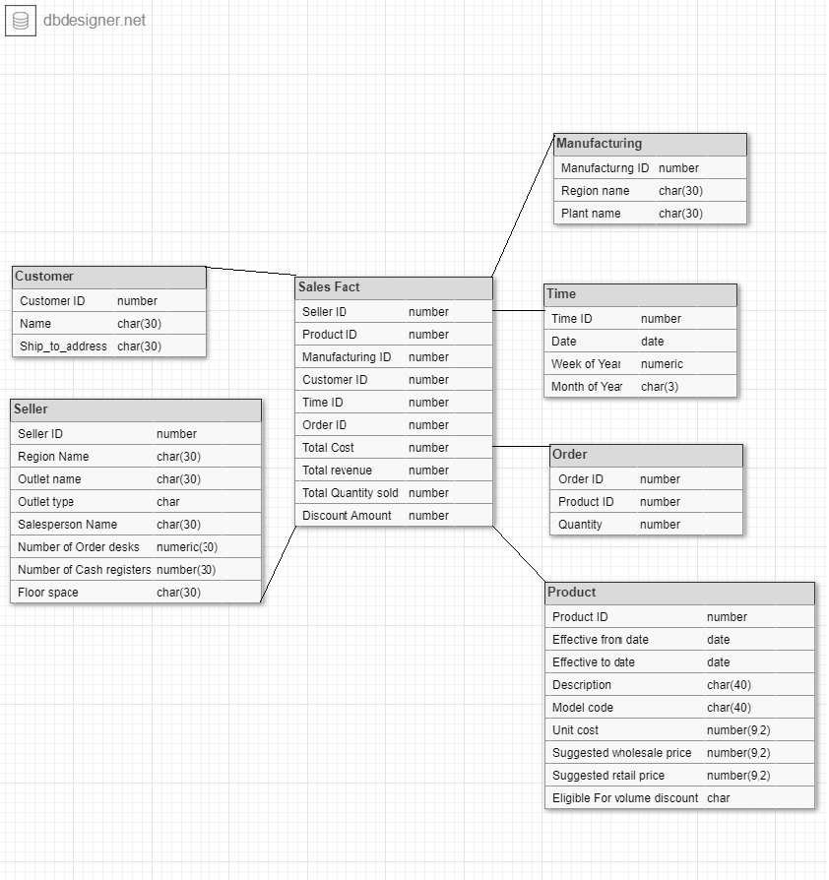

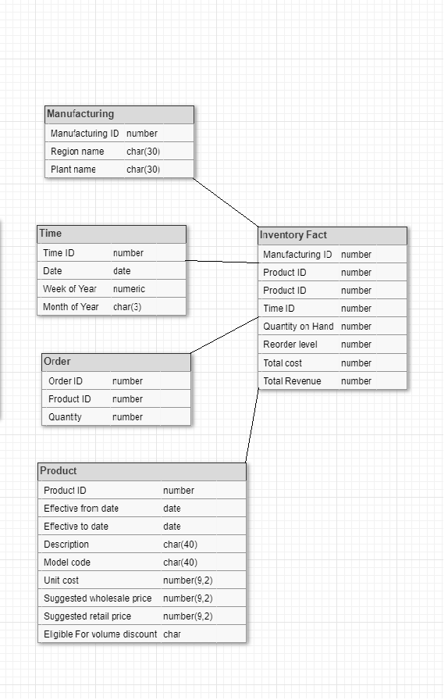
Final Data Warehouse Model
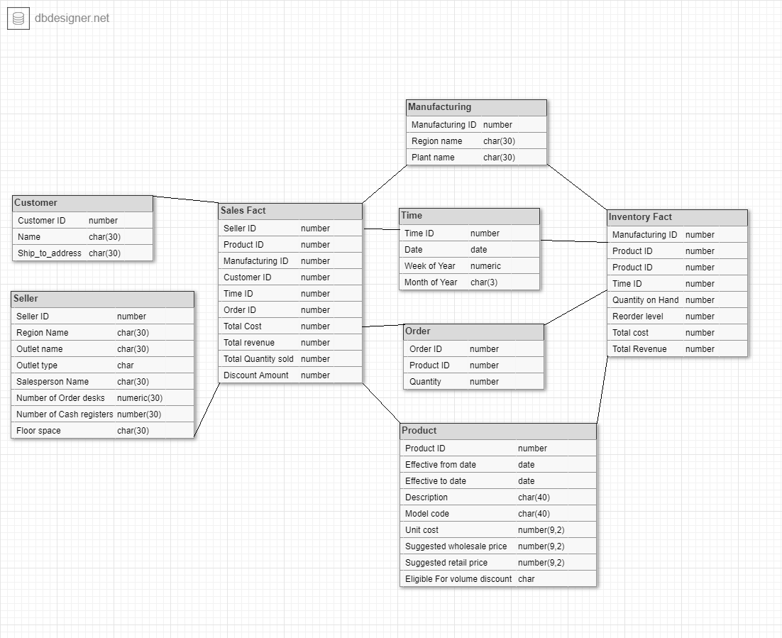
Presented by
Mainak Banerjee
Sujata Paul
Group 4

